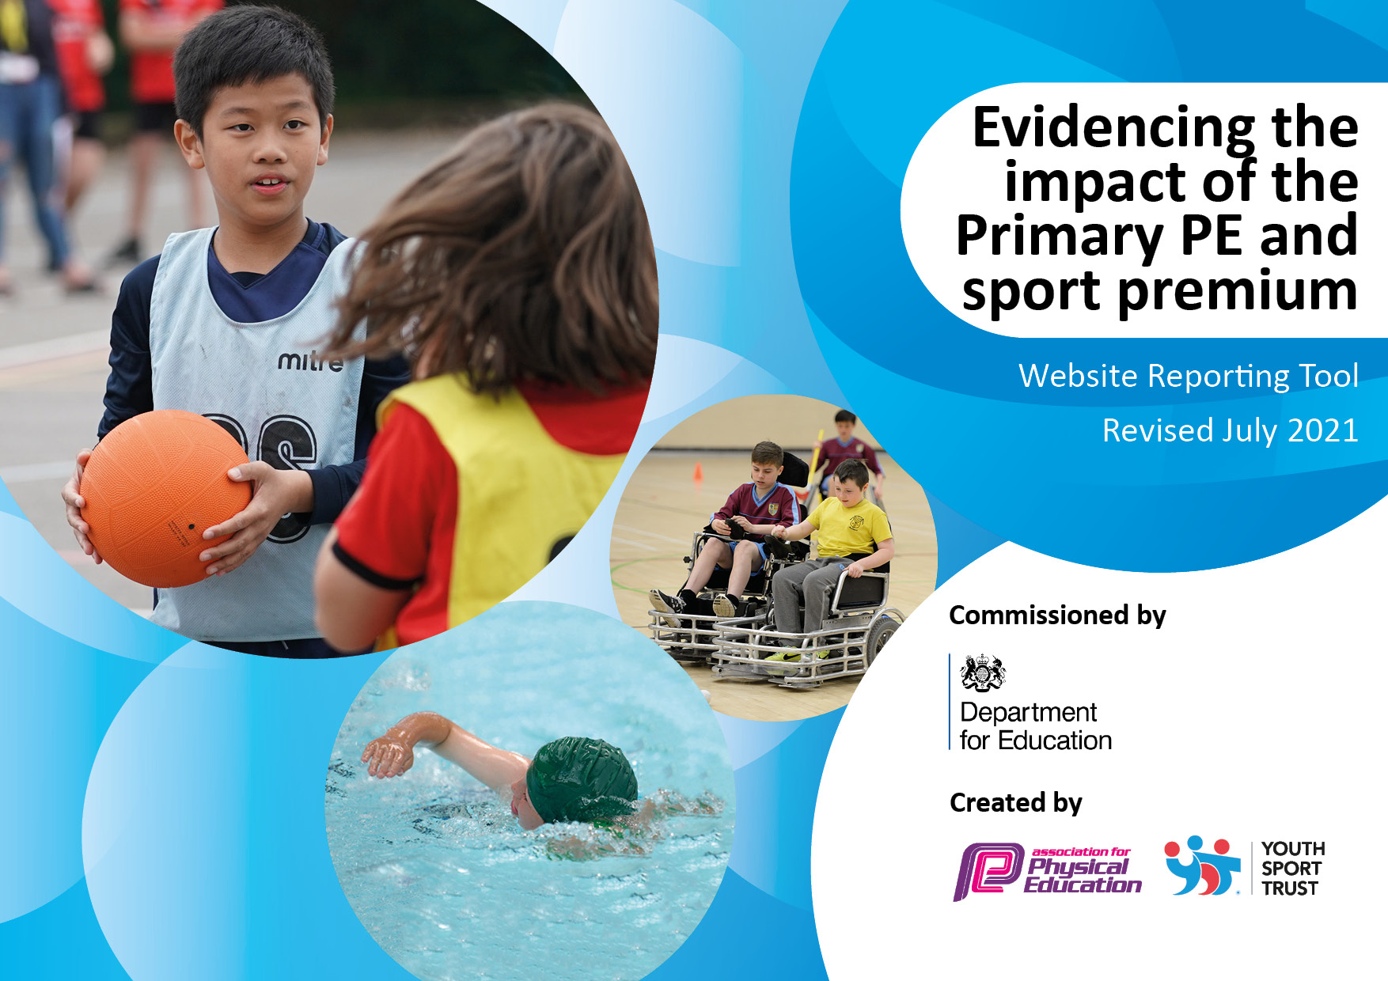
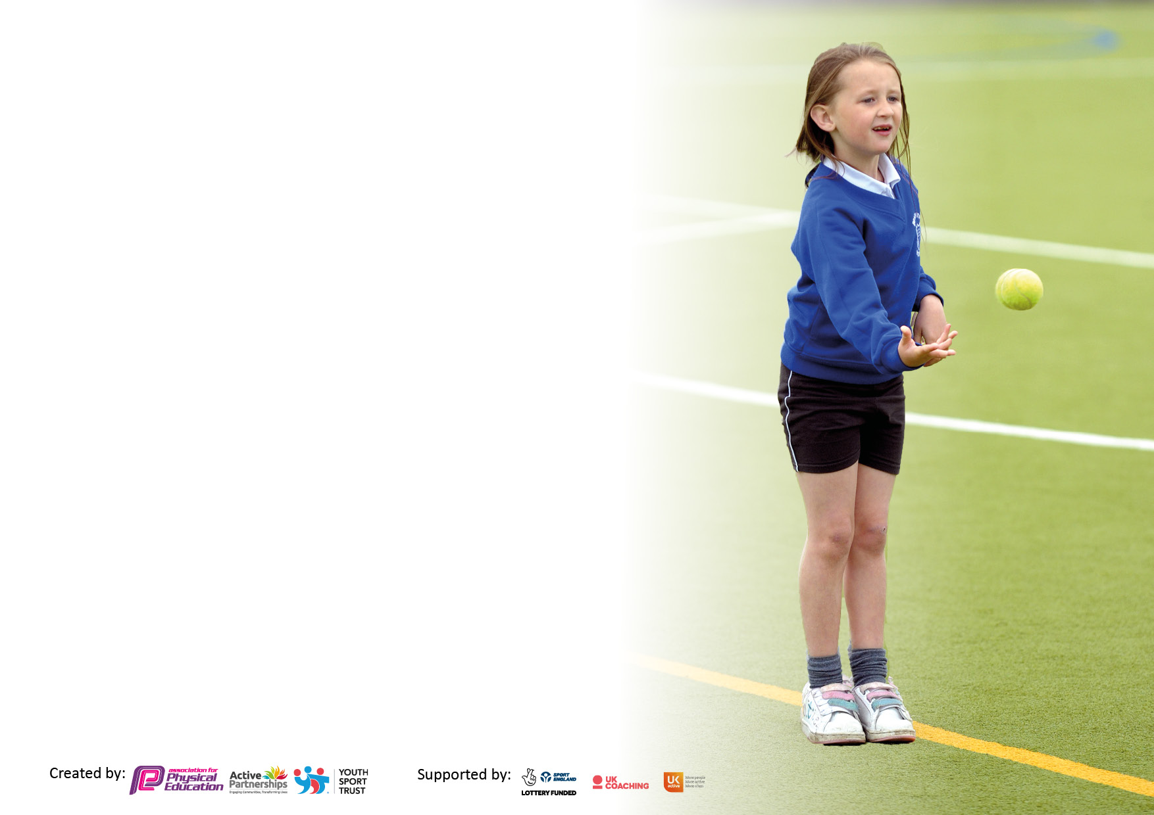

It is important that your grant is used effectively and based on school need. The Education Inspection Framework makes clear there will be a focus on ‘whether leaders and those responsible for governors all understand their respective roles and perform these in a way that enhances the effectiveness of the school’.

Under the Quality of Education Ofsted inspectors consider:
Intent - Curriculum design, coverage and appropriateness
Implementation - Curriculum delivery, Teaching (pedagogy) and Assessment
Impact - Attainment and progress

To assist schools with common transferable language this template has been developed to utilise the same three headings which should make your plans easily transferable between working documents.

Schools must use the funding to make additional and sustainable improvements to the quality of Physical Education, School Sport and Physical Activity (PESSPA) they offer. This means that you should use the Primary PE and sport premium to:

- Develop or add to the PESSPA activities that your school already offer
- Build capacity and capability within the school to ensure that improvements made now will benefit pupils joining the school in future years
- The Primary PE and sport premium should not be used to fund capital spend projects; the school’s budget should fund these.

Pleasevisitgov.ukfortherevisedDfEguidanceincludingthe5keyindicatorsacrosswhichschoolsshoulddemonstrate animprovement.Thisdocumentwillhelpyoutoreviewyourprovisionandtoreportyourspend.DfEencouragesschools to use this template as an effective way of meeting the reporting requirements of the Primary PE and sport premium.

We recommend you start by reflecting on the impact of current provision and reviewing the previous spend.

Schools are required to publish details of how they spend this funding, including any under-spend from 2019/2020, as well as on the impact it has on pupils’ PE and sport participation and attainment. All funding must be spent by 31st July 2022.

We recommend regularly updating the table and publishing it on your website throughout the year. This evidences your ongoing self-evaluation of how you are using the funding to secure maximum, sustainable impact. Final copy must be posted on your website by the end of the academic year and no later than the 31st July 2021. To see an example of how to complete the table please click HERE.

Details with regard to funding
Please complete the table below.

Total amount carried over from 2019/20 | £ 7,244.00
Total amount allocated for 2020/21 | £19380
How much (if any) do you intend to carry over from this total fund into 2021/22? | £4,997
Total amount allocated for 2021/22 | £19,380
Total amount of funding for 2021/22. To be spent and reported on by 31st July 2022. | £ 24,377
Swimming Data
Please report on your Swimming Data below.

Meeting national curriculum requirements for swimming and water safety.

N.B. Complete this section to your best ability. For example you might have practised safe self-rescue techniques on dry land which you can then transfer to the pool when school swimming restarts.
Due to exceptional circumstances priority should be given to ensuring that pupils can perform safe self rescue even if they do not fully meet the first two requirements of the NC programme of study
What percentage of your current Year 6 cohort swim competently, confidently and proficiently over a distance of at least 25 metres?  N.B. Even though your pupils may swim in another year please report on their attainment on leaving primary school at the end of the summer term 2020.  Please see note above | 90%
What percentage of your current Year 6 cohort use a range of strokes effectively [for example, front crawl, backstroke and breaststroke]?  Please see note above | 70%
What percentage of your current Year 6 cohort perform safe self-rescue in different water-based situations? | 50%
Schools can choose to use the Primary PE and sport premium to provide additional provision for swimming but this must be for activity over and above the national curriculum requirements. Have you used it in this way? | Yes/No

Action Plan and Budget Tracking
Capture your intended annual spend against the 5 key indicators. Clarify the success criteria and evidence of impact that you intend to measure to evaluate for pupils today and for the future.

Academic Year: 2020/21 | Total fund allocated: | Date Updated:
Key indicator 1: The engagement of all pupils in regular physical activity – Chief Medical Officers guidelines recommend that primary school pupils undertake at least 30 minutes of physical activity a day in school |  |  |  | Percentage of total allocation:
 |  |  |  | 30.7 %
Intent | Implementation |  | Impact
Your school focus should be clear what you want the pupils to know and be able to do and about  what they need to learn and to  consolidate through practice: | Make sure your actions to achieve are linked to your intentions: | Funding allocated: | Evidence of impact: what do pupils now know and what can they now do? What has changed? | Sustainability and suggested next steps:
Increased physical activity during break and lunchtimes.  Play leaders/IG Sports  Increase in total number of extra-curricular clubs being offered at ks2  Increasing the opportunities for 30 mins physical activity to be achieved  (see indicator 4 for more details) | A wide range of sports/play equipment available for ks2 pupils every lunchtime.  Experienced sports coaches deliver sessions to pupils at lunchtime  Increased programme of extra-curricular clubs | £500  £6987 | Pupils have the opportunity to engage in a wide range of physical activities from traditional games such as basketball to Frisbee/skipping.  Increased opportunities provided for Oakfield pupils. | This model is sustainable, however will require the “topping-up” of equipment/resources each year.  Recording of pupil data to see impact of this initiative e.g how many pupils take part each day over a set period  (Term or half-term.)
Key indicator 2: The profile of PESSPA being raised across the school as a tool for whole school improvement |  |  |  | Percentage of total allocation:
 |  |  |  | 2.3 %
Intent | Implementation |  | Impact
Your school focus should be clear what you want the pupils to know and be able to do and about  what they need to learn and to  consolidate through practice: | Make sure your actions to achieve are linked to your intentions: | Funding allocated: | Evidence of impact: what do pupils now know and what can they now do? What has changed? | Sustainability and suggested next steps:
Inter-form Games;  Additional hour of competitive sport for whole school.  Pupils learning and displaying the Core Inter-form values of Team work, Respect, Enjoyment, Sportsmanship  Reward Stickers | Staff cover for the day.  Reward pupils for positive attitude, effort and learning behaviours. | £500  £67.65 | Whole school competition. Pupils learning and displaying the Core Inter-form values of Team work, Respect, Enjoyment, Sportsmanship  Pupils know that we value positive learning behaviours and reward them for working hard in lessons. | Continue to re-integrate inter-form games, back to 1 x games per term  Evaluate the effectiveness of reward stickers through pupil voice.

Key indicator 3: Increased confidence, knowledge and skills of all staff in teaching PE and sport |  |  |  | Percentage of total allocation:
 |  |  |  | 20%
Intent | Implementation |  | Impact
Your school focus should be clear | Make sure your actions to | Funding | Evidence of impact: what do | Sustainability and suggested
what you want the pupils to know | achieve are linked to your | allocated: | pupils now know and what | next steps:
and be able to do and about | intentions: |  | can they now do? What has
what they need to learn and to |  |  | changed?:
consolidate through practice:
Training for 1 x full time P.E teacher  Department time to redevelop ks2 curriculum. This will include the planning of new curriculum, the creation of schemes of work/lesson plans that tie-in with new “I can” assessment model.  Real P.E  AFPE Annual Membership  I-PADS X 3 | Primary P.E conference  (11th March)  Department days –  (Both full-time p.e staff working together solely on curriculum matters during Summer Term 4 and 5)  Addition of Real P.E should inspire confidence amongst non-specialist staff that deliver p.e as the resources can be used as an aide during the lessons. They also contain video demonstrations of all  Warm-ups/lessons.  Professional development for p.e staff, keeping upto date with latest pedagogy.  Will enable live feedback for pupils as well as being used for assessment/registering and safeguarding in p.e | £250  (cover and cost of course)  £500  £1995  For whole school access  £180  £969.96 | Information/Knowledge gained will aid the development of ks2 curriculum and assessment.  More inclusive curriculum.  Increased engagement in lessons.  Synchronicity between curriculum, lesson plans and assessment.  Pupils will benefit from a consistent approach to fundamental skills building in p.e.  Including Dance, Gymnastics and home learning.  Pupils will be able to see live demonstrations on the field through watching the ipad. Pupils will also be able to review and evaluate their own and others performance | Information disseminated to P.E team and resources shared.  Real P.E purchased for ks2 curriculum 2022/23 as a consequence of attending the course (see below).  Trial of the Real p.e. format has begun and will be reviewed as to its’ impact and success on a termly basis.
Key indicator 4: Broader experience of a range of sports and activities offered to all pupils |  |  |  | Percentage of total allocation:
 |  |  |  | 14.6%
Intent | Implementation |  | Impact
Your school focus should be clear | Make sure your actions to | Funding | Evidence of impact: what do | Sustainability and suggested
what you want the pupils to know | achieve are linked to your | allocated: | pupils now know and what | next steps:
and be able to do and about | intentions: |  | can they now do? What has
what they need to learn and to |  |  | changed?:
consolidate through practice:
Additional range of clubs provided this year has included…  Cross-Country  Multi-sports  Tennis  Basketball club  Softball equipment purchased and now part of the “Striking & Fielding”  Curriculum  TOP-UP Swimming | Cross country club is now taking place each week for ks2 with a committed group of pupils who attend each week.  Multi-sports club is also running weekly with a committed group of pupils who attend each week.  Tennis due for summer terms 5&6  Equipment needed to successfully run the club. Ks2 Tennis raquets  Correct size basketballs purchased and match quality balls purchased.  Entry to Jr NBA Uk scheme  Pupils will now try Softball during the summer term curriculum.  Pupils that have not met the 25m requirement at the end of their swimming unit, undertake additional TOP-UP sessions | £620 2 x Busses to attend fixtures  Equipment total spend for above sports =£1281.77  £1671.40 | Pupils have taken part in 2 x extra-curricular Cross country competitions which has deepened their interest in the discipline and has furthered their understanding of what is required to be a good cross country runner.  Wider experience of a range of sports offered/experienced at ks2.  Pupils have a greater depths of understanding regarding rules and competitive play. Pupils also have the opportunity to improve techniques such as top-spin, lobs, volleys etc.  Lay-ups, rebounding, dribbling can all be looked at in more-depth as well as full basketball rules applied  A new sport for pupils to experience with equipment that they would not have used previously.  Pupils can achieve 25m swim and self-rescue techniques. | Continued entry into cross-country events. Consider a membership with Uk or Somerset Athletics to help further embed cross-country at Oakfield. Consider Cross-Country addition to curriculum.  This is sustainable as we now have the equipment to run clubs and add to curriculum  Continue club running each year. Potential for indoor tennis club during winter?  Look for more opportunities to compete against other schools.  Opportunity for after school club?

Key indicator 5: Increased participation in competitive sport |  |  |  | Percentage of total allocation:
 |  |  |  | 14.5%
Intent | Implementation |  | Impact
Your school focus should be clear | Make sure your actions to | Funding | Evidence of impact: what do | Sustainability and suggested
what you want the pupils to know | achieve are linked to your | allocated: | pupils now know and what | next steps:
and be able to do and about | intentions: |  | can they now do? What has
what they need to learn and to |  |  | changed?:
consolidate through practice:
Provide additional competitive sport opportunities through expenditure on transport to enable more tournaments/games to be attended.  Basketball backboards installed for use at playtimes and during curriculum time. | Additional competitions/fixtures sought and entered.  Hockey x 2  Cross country x 2  Football x 2  Netball x 1  4 x Basketball backboards  Pupils now play competitive basketball at break and lunch times and during curriculum time | £3000  £552.00 | Increase in understanding of high quality competition. What it is like to compete and what as an individual/team they must do to improve further.  Increase in number of pupils taking part in after-school basketball club. | Continue to seek out opportunities for competition in a wide range of sports  IG Sports to run basketball competitions at lunchtimes for yr 5 and 6 separately.

Signed off by
Head Teacher:
Date:
Subject Leader: | Peter Fowler
Date: | 07/08/22
Governor:
Date:

